Lancashire Enterprise Partnership Limited

Private and Confidential: NO

Date: Tuesday, 7th September 2021

LEP - COP 26 - Annual Climate Change Conference - Glasgow

Report Author: Anne-Mare Parkinson, anne-marie.parkinson@lancashirelep.co.uk

Executive Summary

This report provides the Lancashire Enterprise Partnership (LEP) Board with an update on the national and local arrangements in respect to the United Nations Annual Climate Change Conference Cop 26 – Glasgow.

Recommendation

The Lancashire Enterprise Partnership (LEP) is asked to:

- Note the contents of this report.

- Note that a successful expression of interest to COP26 organisers means that North West representatives will participate in the Green Zone at COP26 in Glasgow.

- Note that BEIS has provided funding to regions for local activities, which will require an equal level of match funding. This will be formalised via a Grant Funding Agreement.

- Note a LEP contribution of £5,000 to support the Glasgow activities.

- Note that North West LEPs will participate in the Glasgow activities and regional programme, to be overseen by a steering group in consultation with a wider stakeholder panel.

Background and Advice

United Nations Climate Change Conference - COP26

The United Nations Climate Change Conference, known as COP26 (https://ukcop26.org/) will take place in Glasgow over a fortnight from 31st October to 12th November. This conference is a major milestone in international efforts to combat climate change. COP takes place every year, but every five years the conference is a more significant decision making forum, and Glasgow (co-hosted with Italy, delayed from 2020) is one such event. Previous 5-year events have resulted in the politically significant Koyoto Agreement and the 2015 Paris Agreement. The world will be watching the Glasgow event this year.

The UN Climate Change Conference COP26 is branded as Together for Our Planet.

The Conference will have 2 main zones:

- Blue Zone: Held at the Scottish Events Campus (SEC) for International negotiations; and
- Green Zone: Held at the Glasgow Science Centre for the UK Government Showcase.

There are four overarching strands to the International negotiations:

- Mitigation: Secure global net zero and keep 1.5 degrees within reach
- Adaptation: Urgently adapt to protect communities and natural habitats
- Mobile Finance
- Collaboration: Work together to deliver

As well as the strands to negotiation, there are also five UK Presidency themes which the conference will be focusing on:

- Adaptation and resilience
- Nature
- Energy
- Transport; and
- Finance

The organisers of COP26 invited expressions of interest for UK organisations to take part in the event. A consortia bid by NW LEP’s, including; Lancashire LEP, Cumbria LEP, Cheshire and Warrington LEP, Greater Manchester Combined Authority and Liverpool City Region Combined Authority, was submitted for the Green Zone and was successful in part, to host a youth focused event and other fringe panels and exhibitions. This is due to take place at Glasgow at 4pm on the 7th November. Further details will emerge over the coming weeks, which will allow potential attendees to be identified from across the North West.

COP unit published the high-level Presidency programme of theme days for the main COP event on Glasgow (as below), and associated press release.

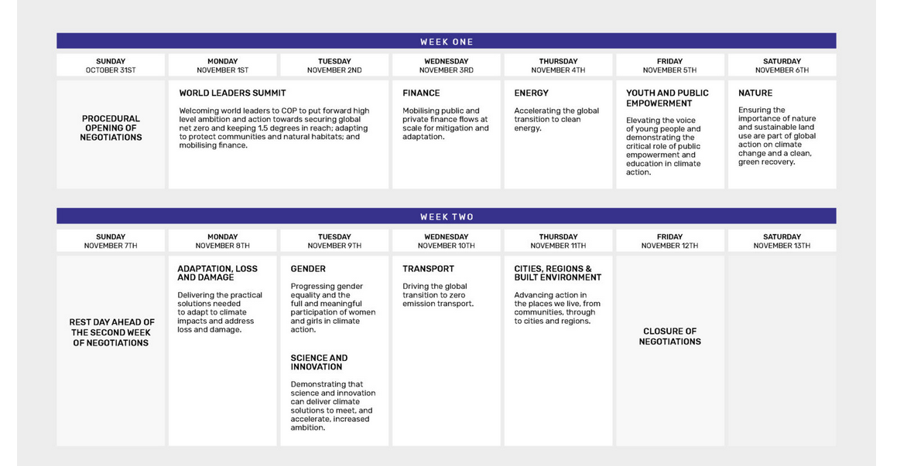

Senior leaders and business representative from the North West will also attend Glasgow and participate in discussion panels, around the theme for that day. The North West itinerary, subject to confirmation is currently:

- 10th Nov (PM) – North West Dinner
- 11th Nov (AM) – North West Breakfast
- 11th Nov (PM) – North West Drinks Reception

Arrangements require further detail before invitations can be concluded.

NORTH WEST DOMESTIC CAMPAIGN

In addition to the main conference, there is the COP26 Domestic Campaign, a local energy and climate policy activity. A principal aim is to gather local narratives around projects that have been delivered and their impacts, as well as showcasing what individuals and organisations can do now to support Government’s Net Zero ambitions. Objectives are to:

- better understand and collect supporting evidence of impacts of funding spent on Net Zero by Local Authorities (LAs).
- understand better the work done by community groups on net zero.
- understand barriers to further work by these two sectors.
- understand better the SME landscape, including opportunities

BEIS has offered funding to the North West region via the Local Energy North West Hub. This funding, for a COP26 Domestic Campaign’ is to support local events and gathering of case studies in support of COP26.

A proposed North West programme of activities has been developed by a steering group comprised of NW LEP representatives and in consultation with the wider North West Net Zero group. This programme will:

- Organise a series of flagship events and site visits in October to coincide with a national Roadshow, with an electric bus linking events across the UK

- Gather 125 case studies that will be promoted on the local energy hub website and a national platform to be agreed with BEIS.

- Organise three North West events (Green Zones) aligned with COP26 themes, to take place during the COP26 fortnight and be showcased in Glasgow.

Other organisations in the North West will be delivering events linked to COP26, including universities and local authorities. LEPs can ensure that the events in their area are signposted and cross marketed. Growth Hubs are also engaged to promote the national campaign for SMEs to sign up to net zero pledges.

The Local Energy Hubs are governed and overseen by management boards comprised of representatives from Local Enterprise Partnerships. These boards have some discretion over how the BEIS defined scope of the COP26 Domestic Campaign is delivered. Government is expecting that a budget is raised locally (both monetary and in kind) equivalent to the funding provided from central government.

The Local Energy North West Hub is directed by the five LEPs in the North West and is coordinating activity to design North West COP26 activities. Planet Mark are the tour operators, and Carbon Copy is responsible for the collation of the case studies

Flag Ship and Site Visits (Planet Mark event organisers)

A national roadshow will take place in advance of COP26. An electric bus promoting action on climate to businesses and communities will stop at destinations across England and Wales. The roadshow will visit the North West between 29th September and 13th October. The Roadshow events, organised between the host and Planet Mark, will engage audiences on focused topics. These events will be designed to draw in interest from across an individual LEP area.

The roadshow will also make visits to key locations (site visits) to capture videos and interview to highlight a recent success story. To mitigate the risk associated with short timescales for arranging these visits, LEPs in the North West have discretion to finalise the locations and content. Site Visits events will be concluded following finalisation of the flagship events, depending on the logistics.

The dates when the roadshow will be in Lancashire are the 11th-12th October 2021.

Flag Ship – These events are about pulling stakeholders together to tell their success stories. A live audience (covid restrictions may apply) + digital streaming. This audience could be for businesses, youth, public sector and / or community organisations. The Planet Mark campaign brings in with it the Race to Zero, encouraging businesses and other organisations to pledge Net Zero. See below information pack in terms of content for the events. Planet Mark over the past few months have also directly liaised, with all Lancashire Local Authorities and Growth Hubs, to ensure the widest possible engagement.

The ‘flagship’ events will be approx. 3 hours in length, include circa 90 mins of short presentations by local organisations sharing real world example of action. An introduction or keynote can be included. The live event should enable networking to take place between attendees, covid restrictions allowing. These events can be extended into a full day, or be incorporated into an existing event. The venue should be located at an iconic location to Lancashire. It needs to be accessible, carbon friendly, with good wi-fi, and at a location where the bus charging requirements can be met.

The roadshow will include content provided by the bus tour provider, a 45 minute carbon jargon session – UN Race to Zero. An online webinar for each hub region will be promoted after the event: Net Zero Carbon Essentials.

Revenue funding from BEIS will be allocated to facilitate these events, with delivery organisations to evidence the match contributions that have been made. BEIS have asked us to endeavour to match all the funding we receive. In-kind contribution can be classed as match as long as they can be evidenced.

In terms of the Lancashire Flagship the NW Energy Hub have confirmed this will take place on the 11th October 2021. A number of potential Lancashire locations have been discussed with the event organisers, Local Energy North West Hub and Planet Mark. The preferred location, subject to confirmation of logistics is Townley Hall, Burnley. A beautiful setting, at the heart and spirit of the industrial revolution, which links to the progression through to Lancashire key sector 'Advanced Manufacturing'. It is envisaged the theme of Lancashire's flagship event will be; innovation, emerging technologies, energy etc.

Site Visits - The roadshow will also make visits to key locations (site visits) to capture videos and interview to highlight a recent success story. To mitigate the risk associated with short timescales for arranging these visits, LEPs in the North West have discretion to finalise the locations and content, and these locations must be accessible to the electric bus, accounting for the need to access charging points and parking.

The site visits will be captured by the bus tour provider as interviews and will count as a case studies for that region. Since these must align with the location of the bus, the energy hub will work with LEPs to agree these.

Site visit examples as per links below.

https://www.youtube.com/watch?v=8XMzTo8glOY
https://www.youtube.com/watch?v=yxFe2zj263c

The potential dates for Lancashire Site Visit/s are 11th - 12th October 2021. Due to logistical arrangements for the Electric Bus, the NW Energy Hub has advised site visits (location, time, arrangements) can only be considered following finalisation of the Flag Ship event arrangements. it is envisaged to finalise site visits by mid-September.

Case Studies

BEIS has provided outline requirements for case studies. A North West scope for case studies has been developed. This is designed to ensure that case studies are captured from across the geography and are gathered in sufficient time to be presented in November.

Local Authorities and Growth Hubs have also been engaged directly to put forward case studies. Organisations that have expressed interest in Glasgow may provide case studies where there is a recent success that can be promoted. There will be coordination with Growth Hubs, DIT and BEIS Cities and Local Growth and other regional agencies.

It is expected that the case studies will be created, collated, and presented openly for other LAs and communities to access through an online platform. The videography, photography, write ups and interviews will be used to create the case studies, which will be covering the following categories:

- Business
- Local government
- Public (including individual stories)
- Community (including youth, face, etc.)
- Tech (including sector retrofit and new built)
- D&I and innovation (including EV, hydrogen and heat) projects

Total number of case studies collated by the NW Hub is 125 with at least 10 per each category specified above.

A case study template is expected to be provided within the next week, which will be distributed to all Lancashire partners.

COP 26 North West Regionally Events (Green Zones)

The events will take place during the fortnight of COP to mirror themes and activity in the Green Zone in Glasgow and showcase north west activity and projects to public, delegations, and investors in regard to those themes. These activities could be digitally linked to Glasgow and other Regional Green Zones across the UK through online participation in and streaming of events. They are organised thematically around the high-level Presidency programme of theme days for COP ( press release.)

They will be branded as a North West events, and use branding from COP26 main event, including as stipulated under the LA guidelines for Together for Our Planet.

The North West event will aim to attract sponsorship to support delivery of the event. The sponsorship will contribute to the evidence of regional match for all LEP areas. Sponsorship should not be linked to the Oil and Gas sector by stipulation from BEIS.

In terms of the North West, there will be 2 Green Zones, with the venues in Manchester and Liverpool agreed. The event is branded 'North West', with speakers, content and attendees' representative of all 5 LEP Areas.

The Green Zone regional events across the fortnight, are themed, and fall on the same day as the themed activities in Glasgow Presidency Programme. For the North West these include:

- North West Green Zone (Liverpool) is scheduled to take place on 4th Nov – COP Theme 'Energy – Accelerating the transition to clean energy'.
- Manchester Green Zone (Manchester) is scheduled to take place on 9th Nov – COP Theme Science and innovation – Demonstrating science and innovation can deliver climate to meet, and accelerate, increase ambition.'

All arrangements discussed in this report will be considered in the context of wider activities taking place across Lancashire, two of which for your information are included below. Should Members be aware of other related climate change activities / events or potential case studies please forward these to Anne-marie.parkinson@lancashirelep.co.uk

Whilst these events do not take place when the roadshow will come through Lancashire on the 11-12th October 2021, they will provide great case studies and potentially production feed into the Green Zones, feeding into Glasgow main event.

Walk Cop 26 – 22nd Oct 21

Lancaster Uni COP 26 Climate Change Festival 20-27th Oct 21 https://www.lancaster.ac.uk/future-places/news/introducing-cop26-at-lancaster-festival-1

Innovation Festival 4-8 October 2021 (Maya Ellis)

FUNDING

Lancashire Events – Government is able to provide up to £11,000 to support the delivery of events (flagship, site visit, case studies) taking place in Lancashire, however it is expected this would be matched (this can be in-kind e.g. venue hire). It is envisaged with the exception of catering, costs can be kept to a minimum with Planet Mark providing all the Visual / IT / Comms requirements for the Flag Ship, Site Visits and Case Studies.

Main Conference – The costs associated with the North West attendance at the main conference in Glasgow are to be met by the areas represented and sponsorship. Typical costs will include; hosting the dinner, breakfast, drinks, comms, venue hire etc. To ensure the North West has a strong voice at COP26, and given the number of activities planned in Glasgow, together with sponsorship raised, the Northwest LEPs are being asked to contribute; Greater Manchester and Liverpool (£10k each) with Lancashire, Cheshire and Cumbria (£5k each).

Budgets and arrangements will be formalised in the form of a Grant Funding Agreement over the next few weeks.

List of Background Papers

Paper | Date | Contact/Tel
None
Reason for inclusion in Part II, if appropriate
N/A

